

Activity 4: Assessment report of the toxic substances
on the sediments of major lakes

Trilateral cooperation on Environmental Challenges in the Joint Border Area

Vladimir A. Dauvalter
Institute of North Industrial Ecology Problems of Kola SC RAS,

This publication has been produced with the assistance of the European Union, but the contents of this publication can in no way be taken to reflect the views of the European Union.

INTRODUCTION

Bottom sediments (BS) cores of the river-lake system of Lake Inari – Pasvik River were collected in four lakes (Kuetsjarvi (at five stations) Vaggatem, Ruskebukta, Skrukkebukta) for effect estimation of mining-and-metallurgical integrated plant’s activity on water system status. Maximum concentration of the investigated heavy metals (HM) (Ni, Cu, Co, Zn, Cd, Pb, Hg, As) in the BS surface layers was identified in lake Kuetsjarvi, receiving waste waters from the Pechenganikel integrated plant. HM content decrease in the BS surface layers is observed downstream the Pasvik River from waste water inflow, although contamination is considerably high. In the lakes polluted only by air transport and household sewage no increase in the content of HM emitted into the atmosphere in great amount by the Pechenganikel integrated plant was distinguished in BS surface layers (Ni, Cu, Co, Zn), but great increase of (5-10 times in comparison with the background values) chalcophylic elements (Pb, Cd, Hg and As) concentration was discovered. The average sedimentation rate in the lakes under study appeared to be bigger (1-3 mm/year) than on an average for the lakes of the northern Fennoscandia (less than 1 mm/year). Phosphorus content increase is detected towards BS surface in some lakes which may give evidence of eutrophication process development.

MATERIALS AND METHODS

Metal content and behavior in BS of Lake Inari and the Pasvik River were studied within the Kolarctic Project. BS cores were collected at five stations of Lake Kuetsjarvi (White Stone, Gulf Stream, Salmijarvi, Kolosjoki, Shuonijoki, station Kuetsjarvi – 1, 2, 3, 4, 5 respectively, 42, 23, 10, 12 and 10 m deep), as well as in the reservoirs of the Pasvik River system: Ruskebukta, Vaggatem, Skrukkebukta, 15, 19, 37 m deep respectively (Fig. 1).
The BS cores in the reservoirs under study were taken by BS corer of open gravity type (internal diameter 44 mm) with an automatically closing diaphragm (Skogheim, 1979). The BS cores were divided into 1 cm layers. The thickness of BS layer under analysis is one of the most important parameters because for the reasons explained below. It is quite difficult to collect representative and sufficient by weight samples for chemical analyses if layers less than 1 cm are used as BS surface layers in accumulation areas are very loose and soft and are characterized with moisture of more than 90 %. On the other hand, concentrations of elements determined in heavier layers is less accurate and fail to estimate properly the contamination condition of the modern BS, especially if sedimentation rate is low (for freshwater systems of the northern Fennoscandia ∼1 mm/year, Norton et al., 1992) and there is an intensive biological BS mixing by bottom species.
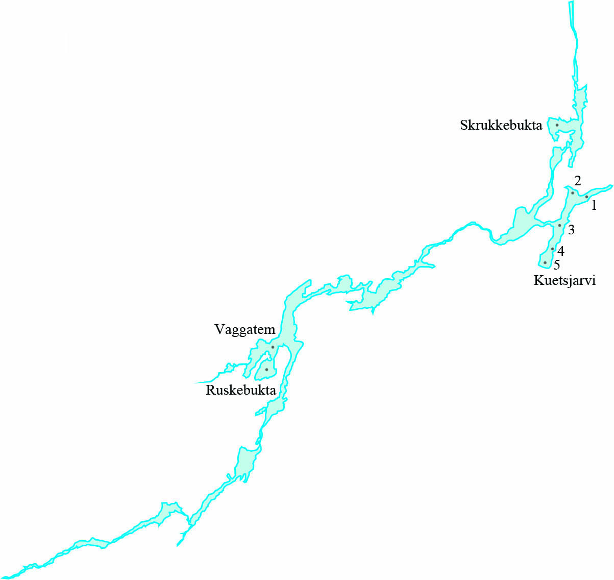
Fig 1. Reservoirs of the Pasvik River and BS sampling stations of Lake Kuetsjarvi under study.

The BS samples were placed in plastic cases and sent for analysis to the laboratory of Institute of the North Industrial Ecology Problems, where they were kept under a temperature 4ºС. The samples (approximately 5 g) were dried in the drying box under a temperature 105ºС for 6 h, and sample humidity was determined. Then the samples were baked in muffle furnace under a temperature 450-500ºС for 4 h in order to determine the loss on ignition (LOI) as indirect indicator of organic substance content. Then, the samples were milled in a jasper mortar and kept under a temperature 4ºС before chemical analysis. For determination of gross metal concentrations 0.4g sample weight was treated with 4ml concentrated nitric acid (HNO₃) of ultra high purity class in autoclave with teflon insert under a temperature 140ºС for 4 h. the autoclave content was then cooled down to room temperature and 2 ml aliquot was put to a 60 ml plastic bottle and diluted with deionized water up to volume 25 ml. the result solution was analyzed by atomic absorption spectrophotometer (AAS-3, Perkin-Elmer). All HM concentrations are expressed in micrograms per gram (µg/g) of dry weight. A detailed description of the methods of sample preparation and chemical analysis is given in (Dauvalter, 1994, 1999).
Industrial impact on the lake ecosystem was determined using the contamination factor (C_{f}) of each priority HM contaminant (Ni, Cu, Co, Zn, Pb, Cd, Hg, and As). The C_{f} value was found by dividing HM concentration in the 1st surface layer by its background content (method of L. Håkanson, 1980, 1984). The contamination degree (C_{d}) was determined by adding all C_{f} values for eight HM for this lake. In this approach the following classification of C_{f}^{i} was used: C_{f}^{i}<1 – low; 1≤C_{f}^{i}<3 – moderate; 3≤C_{f}^{i}<6 – considerable; C_{f}^{i}≥6 – high contamination factor. Similarly, in C_{d} description the classification was used based on the calculation that C_{f} values are summed up for 8 elements: C_{d}<8 – low; 8≤C_{d}<16 – moderate; 16≤C_{d}<32 – considerable; C_{d}≥32 – high degree of contamination indicating serious anthropogenic pollution.
Correlation, factor and cluster analyses using Excel and Statistica packages were carried out for determination of factors that have the greatest influence on formation of chemical composition of the BS.

RESULTS AND THEIR DISCUSSION
Water bodies (and their BS as storage of physical and chemical disintegration products of a wide range of chemical substances) serve as collectors of all substances delivered into their catchment area. BS are an important information source about climatic, geochemical, environmental conditions that existed in the catchment area and in the water body itself, that allows estimating today’s ecological state of the air and aquatic environments. HM concentrations in the BS allow estimating contamination intensity and history of the lakes under study. BS are regarded as a source of ecological information that can be used for different generalizations.

Background concentrations of heavy metals
BS samples taken from the deepest core layers (usually between 20 and 30 cm), allow determinating the HM background concentrations in the course of lake contamination studies. These layers are several hundred years old, i.e. they were formed before the industrial development of the northern part of Fennoscandia. These layers reflect the natural geochemical features of drainage and allow estimating the water body’s contamination extend and also discovering metal concentration anomalies for the purpose of mineral deposits detection (Tenhola, Lummaa, 1989).
The background concentrations of elements and LOI values in the BS of the Pasvik River system’s water bodies are given in Table 1. Statistical parameters were determined without the data from the stations on Lake Kuetsjarvi, as heavily contaminated material from the Pechenganikel integrated plan is intensively accumulated in this lake. Very low amounts of organic material (LOI value in low layers is under 10%) give evidence that the lowest layers of the selected BS cores from Lake Kuetsjarvi are heavily polluted with inorganic material.

Table 1. Background concentrations (in µg/g of dry weight) of heavy metals in the BS of the investigated stations of the Pasvik River system. Average * – average background concentrations in the BS of the North-West of Murmansk Region and border areas of the neighboring countries (Kashulin et al. 2009)
Stations | Cu | Ni | Zn | Co | Cd | Pb | As | Hg
Kuetsjarvi -1 | 64 | 70 | 136 | 39 | 0.23 | 8.3 | 8.4 | 0.108
Kuetsjarvi -2 | 69 | 71 | 152 | 36 | 0.18 | 9.3 | 20.6 | 0.104
Kuetsjarvi -3 | 72 | 65 | 136 | 44 | 0.18 | 9.5 | 15.4 | 0.098
Kuetsjarvi - 4 | 422 | 1083 | 118 | 56 | 0.28 | 5.5 | 12.4 | 0.418
Kuetsjarvi -5 | 345 | 889 | 114 | 44 | 0.26 | 5.5 | 15.0 | 0.402
Vaggatem | 55 | 58 | 126 | 30 | 0.08 | 9.2 | 6.0 | 0.015
Ruskebukta | 62 | 63 | 112 | 26 | 0.09 | 12.4 | 4.4 | 0.038
Skrukkebukta | 58 | 64 | 123 | 25 | 0.09 | 14.0 | 3.9 | 0.021
Average | 58 | 62 | 120 | 27 | 0.09 | 11.9 | 4.8 | 0.025
Minimum | 55 | 58 | 112 | 25 | 0.08 | 9.2 | 3.9 | 0.015
Maximum | 62 | 64 | 126 | 30 | 0.09 | 14.0 | 6.0 | 0.038
Standard deviation | 3 | 3 | 7 | 3 | 0.01 | 2.5 | 1.1 | 0.012
Average* | 33 | 41 | 96 | 16 | 0.17 | 3.2 | 4.6 | 0.040

The maximum background concentrations of most HM (Ni, Cu, Zn, Co, Cd, Hg, and As) were found at the stations of Lake Kuetsjarvi which is accounted for by the fairly high sedimentation rate in the lake, as it has been mentioned before (3 mm/year as it was earlier calculated (Dauvalter, 2002; Dauvalter, 2003) and confirmed by the isotopic dating results), and also geochemical and morphometric peculiarities of the catchment area and the lake itself, with copper-nickel sulphide deposits in its catchment area represented by such minerals as pentlandite (Fe,Ni)₉S₈, chalcopyrite CuFeS₂, cobaltite (Co,Ni)AsS, nickeline NiAs and others (Gregurek et al., 1999). The background concentrations of the above mentioned elements in BS of Lake Kuetsjarvi have been found to be 2-10 times higher than in other lakes under study.
Among the five investigated stations of Lake Kuetsjarvi, the minimum background concentrations of HM in the BS were discovered in the northernmost and the deepest area of the lake – the Pitkjaloukko Bay, where BS core was sampled at station Kuetsjarvi-1, which is related to geochemical nature of lake drainage. The Kuvernerinjoki River (in which catchment area no copper-nickel ore deposits have been discovered) flows into that bay.
The biggest Pb concentrations were detected in the deepest layers of BS cores in Lakes Ruskebukta and Skrukkebukta.
Generally, the average background concentrations of almost all HM (except Cd) in the Pasvik River water bodies’ catchment areas are higher than the average background metal concentrations in BS of the North-West of Murmansk Region and border areas of the neighboring countries (Kashulin et al. 2009)
Two crucial factors influencing chemical composition of the BS background layers were identified by the factor analysis (Table 2). The first factor comprises the natural peculiarities of the Pasvik River drainage. These are physical parameters, such as humidity and LOI, as well as geochemical peculiarities of drainage, primarily, the influence of copper-nickel sulphide deposits and alkali-silicate bedrocks situated in the catchment area. In this factor Cu, Ni, Co, Cd, Pb, Hg, Cr, K, Na, Mg have high coefficients in factor model. As it was mentioned above, copper-nickel deposits are represented by such minerals as pentlandite (Fe,Ni)₉S₈, chalcopyrite CuFeS₂, cobaltite (Co,Ni)AsS, nickeline NiAs, which contain the above mentioned elements in their composition (Gregurek et al., 1999). The weight of the first factor is dominating (53%). The processes in the lake itself are likely to constitute the second factor which has lower weight (25%). These are such processes as biological (and the related biogenic element P), influence of the changes in reductive-oxidative conditions (and the related Mn), increased migration activity of elements (such as Zn), formation of endogenous and authigenic minerals in the water layer and BS (such as calcite CaCO₃) etc.

Table 2. Factor model of chemical composition of all BS background layers of the lakes under study. The most significant parameters with coefficients over 0.7 are highlighted in red.
Parameters | Factor 1 | Factor 2 | Factor 3
Humidity | 0.797 | 0.469 | 0.308
LOI | 0.738 | -0.151 | 0.530
Cu | -0.952 | -0.274 | -0.080
Ni | -0.945 | -0.296 | -0.077
Zn | 0.212 | 0.908 | -0.090
Co | -0.907 | 0.229 | -0.004
Cd | -0.885 | 0.302 | 0.068
Pb | 0.907 | -0.158 | -0.277
As | -0.451 | 0.767 | -0.384
Hg | -0.977 | -0.101 | -0.048
Mn | -0.006 | 0.925 | -0.078
Fe | -0.593 | 0.676 | -0.059
Sr | 0.491 | -0.068 | -0.508
Cr | -0.942 | -0.308 | -0.090
Al | 0.511 | -0.476 | -0.314
K | 0.901 | 0.011 | -0.425
Nа | 0.702 | 0.249 | -0.620
Ca | -0.639 | 0.707 | -0.005
Mg | -0.945 | -0.306 | -0.091
P | 0.062 | 0.870 | -0.006
Factor weight, % | 53.5 | 24.7 | 9.6

Three groups were clearly identified by cluster analysis (Fig. 2): the first group includes channel water bodies (Lakes Ruskebukta, Vaggatem and Skrukkebukta), the second is the water area of Lake Kuetsjarvi with minimum sedimentation rate (stations 1 and 3), where the deepest BS layers are the most approximated to the natural background values and the third is the water area of Lake Kuetsjarvi with the maximum sedimentation rate (stations 4 and 5), where background BS layers, most likely, were never reached. Therefore, this confirms the correctness of the decision that the average background elements concentrations in the Pasvik River BS should be determined exclusive of the stations on Lake Kuetsjarvi.

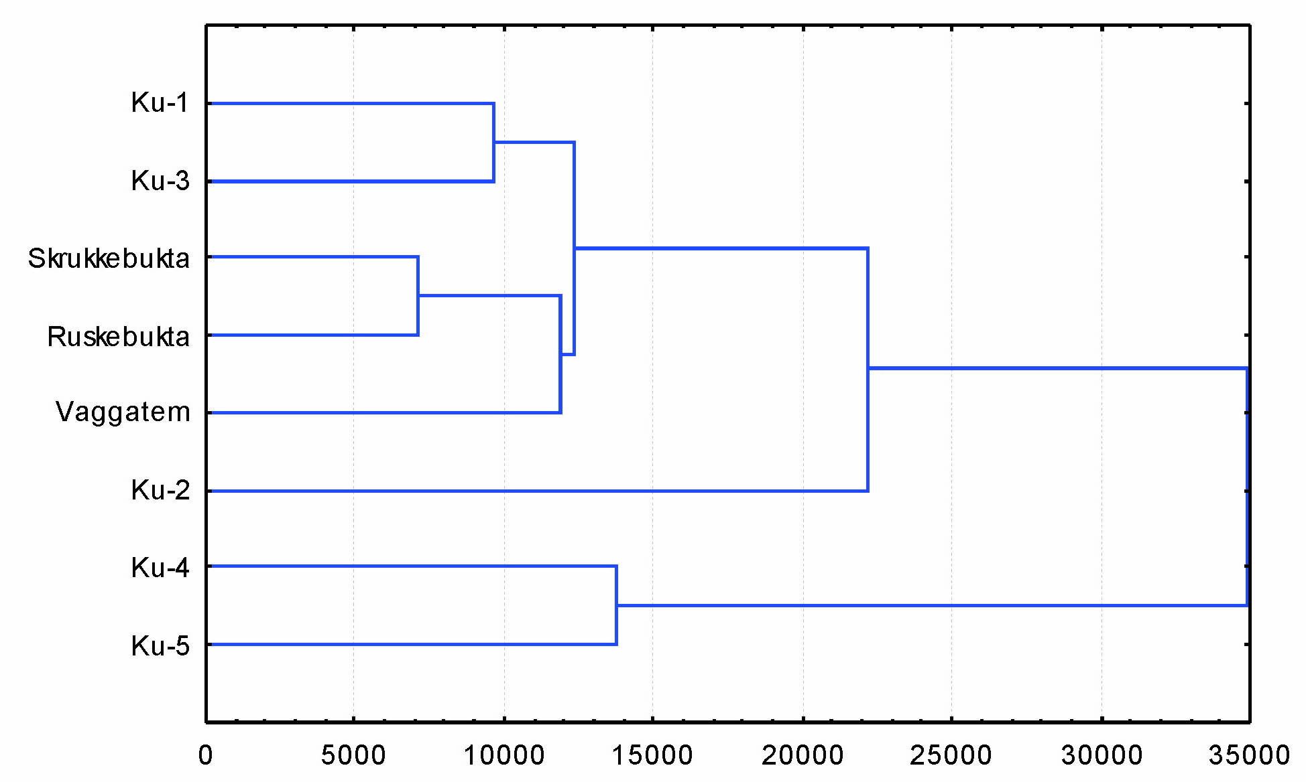
Fig. 2. Cluster analysis dendrogram of background BS chemical composition of the Pasvik River catchment water bodies.

The long-term industrial load on the lakes catchment areas resulted into change of natural conditions of BS chemical composition forming. Consequently, the HM background concentrations play an important role in determination of effect of anthropogenic industrial activity on aquatic ecosystems.

Vertical distribution of elements in the bottom sediments
These investigations are particularly important for the regions with highly developed mining and metallurgical industry, where abnormal distribution of HM is observed due to geochemical peculiarities and pollution influence on the environment (Förstner, 1976).
Waste water from the Pechenganikel integrated plant is the main contamination source of lake Kuetsjarvi and surface waters in the territory of industrial area, where waste waters is directed from the smelters, sludge storages, mines and mine tailings dams. HM (Ni, Cu, Zn, and Fe) and organic substances (xanthates, anionic synthetic surfactant, used in ore flotation concentration) are the main components of the waste waters (Dauvalter, 2002).
Increasing concentrations of the main contaminants discharged by the Pechenganikel integrated plan into Lake Kuetsjarvi via the Kolosjoki River were detected at different depths at different stations of the lake (Fig. 3). HM background values were never reached at stations 4 and 5 situated the closest to the Kolosjoki river mouth, for this reason the data from these stations were not taken into consideration while calculating the average background contents. It is related to the large amount of suspended mineral substances with the plant’s waste water and their sedimentation in the nearest part of the lake. This assumption is also confirmed by low concentrations of organic material in BS of stations 4 and 5 – over 2-4 % in deep layers, then the LOI value increases to 12-14% closer to the BS surface. This explains fairly high sedimentation rate in this water area.
At stations 1-3 increase of the main contamination HM concentration – Ni and Cu – is found beginning from the depth 5, 12 and 6 cm respectively, consequently, taking into consideration the 70-year history of the lake contamination by waste waters from the Pechenganikel integrated plant, sedimentation rate can be calculated ca. 0.7, 1.7 and 0.9 mm/year for the above mentioned stations, respectively. Sedimentation rate in Lake Kuetsjarvi was earlier determined by indirect calculations as 1.5-3 mm/year (Dauvalter, 1995, 1998, 1999, 2002, 2003; Dauvalter, Rognerud, 2001), which, taking into consideration columns from stations 4 and 5 where sampling of BS layers correlating to background values was never done, coincides with our calculations.
Almost all the elements have surface maximums in the BS of Lake Kuetsjarvi (Fig. 3). Zn at stations 4 and 5, Cd at station 4, and As at station 3 make an exception. Mercury is characterized by maximum concentrations at depths 2-4 cm of BS almost at all of the lake stations.

Fig. 3. Vertical distribution of HM concentrations (µg/g) in BS columns of Lake Kuetsjarvi.
Even though the Pechenganikel integrated plant has reduced its HM discharge into lake Kuetsjarvi (for example, Ni discharge decreased from 12.9 to 4.4 t/year from 1990 to 2007, and the atmospheric emission of this HM in that period were approximately the same within 300-350 t/year, according to the official data of Kola Mining and Metallurgical Company - http://www.kolagmk.ru/), the HM concentrations decrease in the BS are not observed in Lake Kuetsjarvi.
It was earlier calculated (Dauvalter, 2002, 2003) that 310 t Ni, 120 t Cu, 14 t Co, 19 t Zn, 0.087 t Cd, 0.78 t Pb, and 0.053 t Hg have been accumulated in the Lake Kuetsjarvi BS for the period of the Pechenganikel integrated plant’s operation.
No significant changes (Fig. 4) were found in the vertical distribution of Ni, Cu, Co, and Zn concentrations in BS of the water bodies situated upstream from the place of contaminated waters inflow from lake Kuetsjarvi – Ruskebukta and Vaggatem, although a slight increase of Ni and Cu concentrations is observed in the upper 4 cm BS of Lake Vaggatem, which is connected with airborne industrial pollution from the Pechenganikel integrated plant. The discovered distribution of the above mentioned HM coincides with the results of BS investigations of Lake Vaggatem in 1988 (Rognerud, 1990), and lakes Rajakoski and Skogfoss situated also upstream from Lake Kuetsjarvi in 1993 (Dauvalter, 1998). However, an increasing trend of chalcophylic elements concentrations (Pb, Cd, Hg, and As) was discovered in the surface layers of Lake Ruskebukta and Vaggatem in comparison with the background content. The greatest increase was observed in Lake Ruskebukta for Hg. This increase, probably, is not directly connected with operation of the Pechenganikel integrated plant, because this part of the Pasvik River catchment area is impacted by the HM discharges from the integrated plant insignificantly (Hagen et al., 1991), but it confirms the conclusion of many ecologists of the global environment pollution by chalcophylic elements, in particular, in the Arctic and Subarctic zones of the Northern hemisphere (Pacyna, Pacyna, 2001). The increase of Pb content rate in lakes upstream from the place of contaminated waters inflow from Lake Kuetsjarvi, probably, was also caused by the global atmospheric pollution of the Northern hemisphere (Norton et al., 1990). Pb inflow into many lakes is associated with its atmospheric deposition with motor vehicle emissions (Lewis, McIntosh, 1989; Norton et al., 1992; Rognerud et al., 1993; Rognerud, Fjeld, 1990). The ban on leaded petrol in the last decades has resulted into reduction of its emission with exhaust gases and some reduction of its content in the uppermost layers of BS in some lakes (for example, Vaggatem, Fig. 4). A slight decrease of Cd concentration is also found in the upper layer in Lake Vaggatem.
As a result of studies of BS chemical composition in the catchment lakes of the White Sea in Murmansk Region concentration increase of chalcophylic elements (Hg, Cd, Pb, and As) was discovered in all water bodies under study regardless of whether they are under airborne industrial load or receive waste waters from industrial enterprises (Dauvalter, 2006).
Fig. 4. Vertical distribution of HM concentrations (µg/g) in the Pasvik River system water bodies’ BS.
In the BS of Lake Skrukkebukta situated downstream from the place of contaminated waters inflow from Lake Kuetsjarvi the maximum concentrations of Ni, Cu, Co, Cd, and Pb were found in the upper 1-cm layer of BS (Fig. 4). A significant increase of HM concentrations as compared to the background was detected in the upper 3 cm of BS in Lake Skrukkebukta. Taking into consideration that the Pechenganikel integrated plant has been the main contamination source of this region already for 70 years, sedimentation rate in Lake Skrukkebukta can be estimated approximately 0.4 mm/year.
Concentration decrease of K, Ca, Mg, and Al is observed towards to BS surface of Lake Kuetsjarvi (Fig. 5) which can be related to the inflow of a large amount of sulphate in the content of waste waters from the Pechenganikel integrated plant, causing release of alkali and alkaline-earth metals and Al from the suspended particles and BS and their transition into a dissolvable form (Baklanov, Makarova 1992). The sulphate content in the water of Lake Kuetsjarvi is 2-3 times higher than in all the other lakes of the Pasvik River system under study. Such regularity was also discovered in BS of Lake Skrukkebukta.
Fig. 5. Vertical distribution of Al, Mg, K and Na concentrations (µg/g) in BS of Lake Kuetsjarvi.

Increase of Fe and Mn concentrations is observed towards the BS surface almost at all the stations on Lake Kuetsjarvi (Fig. 6). This phenomenon is the most obvious at the deepest station 1. The increase of Fe and Mn concentrations in the surface layers of BS is typical both of big lakes – Imandra (Moiseenko et la., 2002; Dauvalter, Ilyashuk, 2007) and Inari (Dauvalter, 1998) and small lakes – Lake Chuna in the Lake Imandra catchment area (Moiseenko et la., 2002), Lake Kutsasjarvi, northern Sweden (Malinovskyi et al., 2005). The maximum Mn content (exceeding bulk earth and background 10-50 times) in the BS thickness of the lakes under study is confined to surface and near-surface layer. The probable reason is that it is in these upper layers where oxidizing conditions are replaced by reducing conditions and poorly soluble oxides Mn⁴⁺ are recovered to the dissolved ion Mn²⁺ when the redox-potential is higher (i.e. with higher concentrations of dissolved O₂), than Fe³⁺ recovery to Fe²⁺. Consequently, the maximum values of Fe concentrations (exceeding bulk earth and background 10 times) in BS can be found both at a large depth, i.e. under conditions of Eh lower value (with low concentrations of dissolved O₂). The better the bottom water layers and BS surface layers are supplied with oxygen, the largest is the depth where BS poorly soluble oxides Fe³⁺ are sedimented (Dauvalter, Ilyashuk, 2007). Fe concentration increase in subsurface layers of BS (Fig. 6) is related to processes of molecular diffusion of dissolved protoxidic forms of Fe in the underlying BS, characterized by anaerobic conditions and having recovering potential, upwards to contact with oxidized zone of the water layer, where they oxidize again, lose mobility and enrich the surface oxidized layer. In (Dauvalter, Ilyashuk, 2007) an assumption was made that Fe and Mn’s accumulation and ferromanganese nodules formation in the North Fennoscandia lakes BS may take place in the presence of three main conditions: 1) the water pH should be neutral and lake acidulation processes should not develop; 2) high content of dissolved oxygen in the whole water layer to the bottom in the absence of processes of lakes eutrophication; 3) lakes should be deep enough – about 15 m and deeper. Probably, the above mentioned lakes and their water areas meet these requirements.

Fig. 6. Vertical distribution of Fe and Mn concentrations (µg/g) in BS of Lake Kuetsjarvi.

In the lakes and stations of Lake Kuetsjarvi under study increase of P content is observed in the surface layers of BS (Fig. 7). The content increase of biogenic element P in the surface layer of BS in the lakes of the Pasvik River system can indicate development of eutrophication processes, related to the inflow of household sewage and the river flow regulation, resulting into the flow deceleration, stagnations, and, finally, accumulation of biogenic elements in aquatic ecosystems. Phosphorus accumulated in BS can be a source of this biogenic element permeating into the water layers, as it was demonstrated by some researchers (Lennox, 1984; Sandman et al., 1990; Shaw, Prepas, 1990).

Fig. 7. Vertical distribution of P concentrations (µg/g) in BS of Lakes Kuetsjarvi (left), Skrukkebukta, Vaggatem, Ruskebukta.

Three main factors influencing chemical composition formation in BS water layer of the lakes under study were discovered by factor analysis. The first factor is effect of discharged waters and emissions from the main polluting enterprise in the territory under study – the Pechenganikel integrated plant. High coefficients are observed for all HM in the factor model (Table 3), and the weight of this first factor is predominant (42 %). This factor is also represented in the negative coefficient of Al and K concentrations – the metals forming a part of the basic rock-forming minerals of the cooper-and-nickel deposits and mines. These metals come as part of dust from mine tailings and slurry storages of the Pechenganikel integrated plant. The second factor with a lower weight (20%) is, probably, natural processes taking place in the water layer and water bodies’ BS, which is evidenced by such parameters as BS humidity and presence of fairly passive and inert metal Cr, as well as Mg. The third factor with the minimal weight (11 %), only has high coefficient of P, but Fe and Mn have fairly high coefficients, which makes it possible to draw a conclusion that this factor comprises reductive-oxidative processes and eutrophication, happening often in parallel in water bodies.

Table 3. Factor model of the general chemical composition in all the BS columns from the lakes under study. The most significant parameters with coefficients more than 0.7 are highlighted in red.
Parameters | Factor 1 | Factor 2 | Factor 3
Layer | -0.481 | -0.227 | 0.414
Humidity | 0.134 | 0.917 | 0.009
LOI | 0.159 | 0.667 | -0.326
Cu | 0.910 | -0.115 | -0.233
Ni | 0.958 | -0.044 | -0.160
Zn | 0.831 | 0.181 | -0.091
Co | 0.914 | 0.098 | -0.093
Cd | 0.933 | 0.170 | -0.138
Pb | 0.758 | 0.404 | -0.419
As | 0.817 | 0.188 | 0.269
Hg | 0.859 | -0.276 | -0.260
Mn | 0.467 | 0.301 | 0.486
Fe | 0.597 | -0.275 | 0.627
Sr | 0.416 | 0.444 | -0.030
Cr | 0.349 | -0.888 | -0.146
Al | -0.783 | -0.001 | -0.248
K | -0.742 | 0.511 | -0.031
Nа | -0.042 | 0.338 | 0.144
Ca | 0.554 | -0.302 | 0.486
Mg | 0.238 | -0.910 | -0.139
P | 0.321 | 0.350 | 0.750
Factor weight, % | 42.4 | 20.3 | 10.8

Vertical distribution of metals in BS of the lakes under study will allow studying historical trends of HM incoming under the influence of various industrial factors. Active metal accumulation is connected with the beginning of industrial activity in the North Fennoscandia. Increased accumulation of chalcophylic elements (Pb, Cd, Hg, and As) in the upper layers of the lake BS is preconditioned by the global air mass transport in the northern hemisphere.

Element distribution in the surface layers of bottom sediments
HM atmospheric emissions by the Pechenganikel integrated plant and waste water from the smelters, slug disposal sites, tailings and mining pits are the main sources of HM increased concentrations in the surface layers of the water bodies’ BS in the Pasvik River system. This is especially intensive in Lake Kuetsjarvi. The water in the Pasvik River system is characterized by neutral pH and has great neutralizing capacity in relation to the great amount of acid compounds coming from the integrated plant. This facilitates catchment and accumulation of mobile HM in the BS (for example, Ni, Cu, Cd) (Håkanson L., Jansson, 1983). The prevailing south-west winds distribute the environmental plume mainly in the north-easterly direction (BS in the lakes at a distance > 20 km south from Nikel are almost pollution-free) (Rognerud et al., 1993). Deposition of these elements with atmospheric precipitations is low in the northern regions of Norway and Finland (Ruhling et al., 1987; Steinnes et al., 1988). Low impact of the integrated plant’s emission on the HM content in the surface layers of BS is observed here (Johansson, 1989; Rekolainen et al., 1986; Rognerud, Fjeld, 1990, 1993; Verta et al., 1989; Dauvalter, 1994, 1995, 1999). The greatest Ni and Cu concentrations increasing the background values 10-380 times are observed at a distance up to 10 km from the Pechenganikel integrated plant (Dauvalter, 1994, 1995, 1999). The background concentration exceeding reduces up to 3-7 times at a distance 10 to 40 km from the pollution source. Co concentrations were 4-10 times higher than the background at a distance of up to 15 km from the pollution source and up to 3 times higher in other lakes, which is an evidence of the melting shops’ emissions impact.
The main part of the industrial waste water from the Pechenganikel integrated plant goes to Lake Kuetsjarvi, in which BS surface layers show the maximum concentrations of all the HM under study (Table 4) among all of the lakes of the Pasvik River system. It was also observed by earlier studies (Moiseenko et al., 1995; Dauvalter, 1995, 1992, 1994). The highest concentrations of HM were observed at the deepest station 1 (Ni, As), at stations 4 and 5 (Cu, Cd, Pb, Hg), situated in the nearest proximity to the Pechenganikel integrated plant waste water discharge area, and also at station 3 (Zn, Co), situated in the nearest proximity to the channel, connecting Lake Kuetsjarvi and the Pasvik River watercourse.

Table 4. HM concentrations (in µg/g of dry weight) in the surface (0-1 cm) BS layer at the stations on the Pasvik River under study
Stations | Cu | Ni | Zn | Co | Cd | Pb | As | Hg
Kuetsjarvi-1 | 2000 | 4978 | 309 | 297 | 3.82 | 32.4 | 147 | 0.536
Kuetsjarvi-2 | 720 | 2870 | 277 | 133 | 1.40 | 26.5 | 51.8 | 0.702
Kuetsjarvi-3 | 1403 | 4425 | 775 | 505 | 3.18 | 35.8 | 118 | 0.808
Kuetsjarvi-4 | 2305 | 3127 | 248 | 183 | 1.83 | 43.9 | 60.7 | 0.760
Kuetsjarvi-5 | 2039 | 3465 | 338 | 244 | 4.04 | 47.0 | 70.5 | 1.000
Vaggatem | 75 | 87 | 122 | 28 | 0.11 | 15.6 | 7.6 | 0.042
Ruskebukta | 67 | 70 | 95 | 21 | 0.15 | 17.2 | 8.5 | 0.161
Skrukkebukta | 169 | 280 | 127 | 39 | 0.27 | 26.8 | 6.9 | 0.017
Average | 1097 | 2413 | 286 | 181 | 1.85 | 30.6 | 58.9 | 0.503
Minimum | 67 | 70 | 95 | 21 | 0.11 | 15.6 | 6.9 | 0.017
Maximum | 2305 | 4978 | 775 | 505 | 4.04 | 47.0 | 147 | 1.000
Standard deviation | 953 | 1996 | 218 | 166 | 1.65 | 11.4 | 52.6 | 0.380
Table 2. Continuation
Stations | Mn | Fe | K | Na | Ca | Mg | Sr | Cr | Al | P
Kuetsjarvi-1 | 48000 | 103448 | 2924 | 535 | 6800 | 9048 | 71 | 119 | 14689 | 5046
Kuetsjarvi-2 | 1895 | 64000 | 5104 | 700 | 6041 | 15241 | 45 | 252 | 26866 | 992
Kuetsjarvi-3 | 6555 | 82059 | 4574 | 765 | 6811 | 15945 | 45 | 275 | 26087 | 2532
Kuetsjarvi-4 | 563 | 75688 | 2897 | 851 | 7378 | 16871 | 42 | 328 | 21972 | 1600
Kuetsjarvi-5 | 656 | 66500 | 3414 | 873 | 8595 | 17059 | 49 | 306 | 24681 | 1240
Vaggatem | 400 | 54307 | 7357 | 680 | 1794 | 13171 | 19 | 117 | 43741 | 1007
Ruskebukta | 360 | 54873 | 5683 | 675 | 1135 | 10161 | 50 | 90 | 31557 | 1889
Skrukkebukta | 570 | 45231 | 6852 | 834 | 1334 | 13643 | 47 | 116 | 34339 | 1309
Average | 7375 | 68263 | 4851 | 739 | 4986 | 13892 | 46 | 200 | 27991 | 1952
Minimum | 360 | 45231 | 2897 | 535 | 1135 | 9048 | 19 | 90 | 14689 | 992
Maximum | 48000 | 103448 | 7357 | 873 | 8595 | 17059 | 71 | 328 | 43741 | 5046
Standard deviation | 16548 | 18552 | 1720 | 114 | 3043 | 2998 | 14 | 99 | 8702 | 1351

In the lower course of the Pasvik River, in Lake Skrukkebukta, the maximum concentrations of Ni, Cu, Co, Zn, Cd, Pb was found in the surface layer of BS which is related to the contaminated water inflow from Lake Kuetsjarvi (Table 4). In this lake conditions for sedimentation of finely dispersed particles, absorbing large amounts of HM on their surface, are created.
Concentration increase of chalcophylic elements (Pb, Cd, As, and Hg) was observed in the upper layers of BS in the lakes of the Pasvik River upper stream (Table 4). Among these lakes great concentrations of chalcophylic elements were observed in Lake Ruskebukta (the highest As and Hg concentrations among the channel lakes of the Pasvik River, i.e. except for Lake Kuetsjarvi) which may be related to the water flow regulation, construction of water-storage reservoirs and formation of As and Hg organic compounds, such as mercury methyl. It proves the fact that atmospheric emissions of the Pechenganikel integrated plant are not the major contamination source of chalcophylic elements and they can be found in the northern regions of Norway and Finland or in the central industrial regions of Europe. Pb content in the environment is influenced by tetraethyl lead – antidetonant in petrol. Another explanation of increased concentrations of chalcophylic elements is connected with their emissions into the atmosphere by the smelters, although in a respectively low (several t/year) amounts (Hagen et al., 1991).
As the melting temperature of chalcophylic elements is lower than that of Ni, Cu, Co, and Zn, almost all of them are transferred to sprays emitted into the atmosphere by smelters and transported over a larger distance (like SO₂) in comparison with other HM. Consequently, increased concentrations of chalcophylic elements may not be found in the proximity to the integrated plant.
The highest Fe and Mn concentrations in the surface layers of BS among the lakes under study were recorded at station 1 of Lake Kuetsjarvi (Table 4), which is related to the large depths of this part of the lake, good oxygen supply of the water layer and upper layers of BS, which results into accumulation of these metals in oxygenized poorly-dissoluble form in the upper layers of BS which has been explained above.
Alkaline-earth metals (Ca, Mg, and Sr) in the highest concentrations are discovered in the surface layer of BS of Lake Kuetsjarvi which is related to the increased inflow of these metals with waste water of the Pechenganikel integrated plant, including suspended condition, which has an impact on accumulation of these metals in the BS (table 4).
Discharge of household waste water from the Nikel settlement and production site of the Pechenganikel integrated plant, agricultural and recreational activities on the shores of Lake Kuetsjarvi have resulted into biogenic load increase and eutrophication process in the lake, mainly in the southern shallow part, which has caused an increased P accumulation in the BS. As a result, maximum content of P was discovered in the surface layers of BS in Lake Kuetsjarvi (Table 4). Increased P content was also observed in Ruskebukta which is related to the water flow regulation and household waste water discharge from the populated localities on lake shores.
Two main factors influencing the formation of chemical composition of today’s BS in the surface 1-cm layer of water bodies under study (Table 5) were identified by factor analysis. The first factor with the greatest weight (57 %) is the development lakes contamination processes. BS humidity, content of all the contaminating HM – Ni, Cu, Co, Zn, Cd, Pb, As, and Hg, which increase their contents in the surface layer of BS and which come from the activity of the Pechenganikel integrated plant and also the main mineral-forming elements Fe, Al, K, and Ca, which in increased amounts are brought into water bodies in connection with mining activity, have the biggest coefficients in the first factor of the factor model. The second factor combines values characterizing the biological activity of water bodies (LOI, P), redox conditions (Mn), as well as some of the main elements in the Earth crust (Na and Mg). Most likely, the processes taking place in the reservoirs play the main role despite of the heavy contamination in Lake Kuetsjarvi.

Table 5. Factor model of chemical composition in general of all the BS columns of the lakes under study. The most significant parameters with coefficients more than 0.7 are highlighted in red.
Parameters | Factor 1 | Factor 2 | Factor 3
Humidity | 0.714 | 0.595 | -0.196
LOI | 0.181 | 0.778 | 0.368
Cu | 0.895 | -0.254 | 0.253
Ni | 0.979 | -0.056 | -0.118
Zn | 0.681 | -0.268 | -0.627
Co | 0.850 | -0.140 | -0.473
Cd | 0.945 | -0.076 | -0.020
Pb | 0.759 | -0.539 | 0.261
As | 0.953 | 0.187 | -0.226
Hg | 0.812 | -0.500 | 0.081
Mn | 0.614 | 0.729 | -0.025
Fe | 0.905 | 0.303 | -0.104
Sr | 0.651 | 0.509 | 0.329
Cr | 0.535 | -0.822 | 0.065
Al | -0.911 | -0.141 | -0.307
K | -0.906 | 0.090 | -0.374
Nа | -0.092 | -0.876 | 0.189
Ca | 0.890 | -0.390 | 0.095
Mg | 0.143 | -0.986 | -0.063
P | 0.660 | 0.717 | -0.082
Factor weight, % | 56.7 | 28.5 | 7.0

Two groups of water bodies were determined by cluster analysis (Fig. 8). The first group is the water area of Lake Kuetsjarvi, heavily contaminated with waste waters of the Pechenganikel integrated plant (stations 2-5). The lakes situated downstream and upstream from the influx place of the contaminated waters from Lake Kuetsjarvi (Skrukkebukta, Ruskebukta and Vagagtem) are the second group of water bodies. They are characterized by less contamination of the BS surface layers due to greater distance from the integrated plant which has been mentioned above. Station 1 of Lake Kuetsjarvi stands apart, probably, because it is the deepest among all of the lake stations and specific physical chemical and geochemical peculiarities of this water area made a contribution to the BS chemical composition. First of all it concerns the maximum content of such elements as Fe, Mn, P sensitively responding to changes in redox potential as well as Ni and As, intensively absorbed by these elements. This station is also characterized by the greatest contamination extent among all the stations under study (see Table 6).
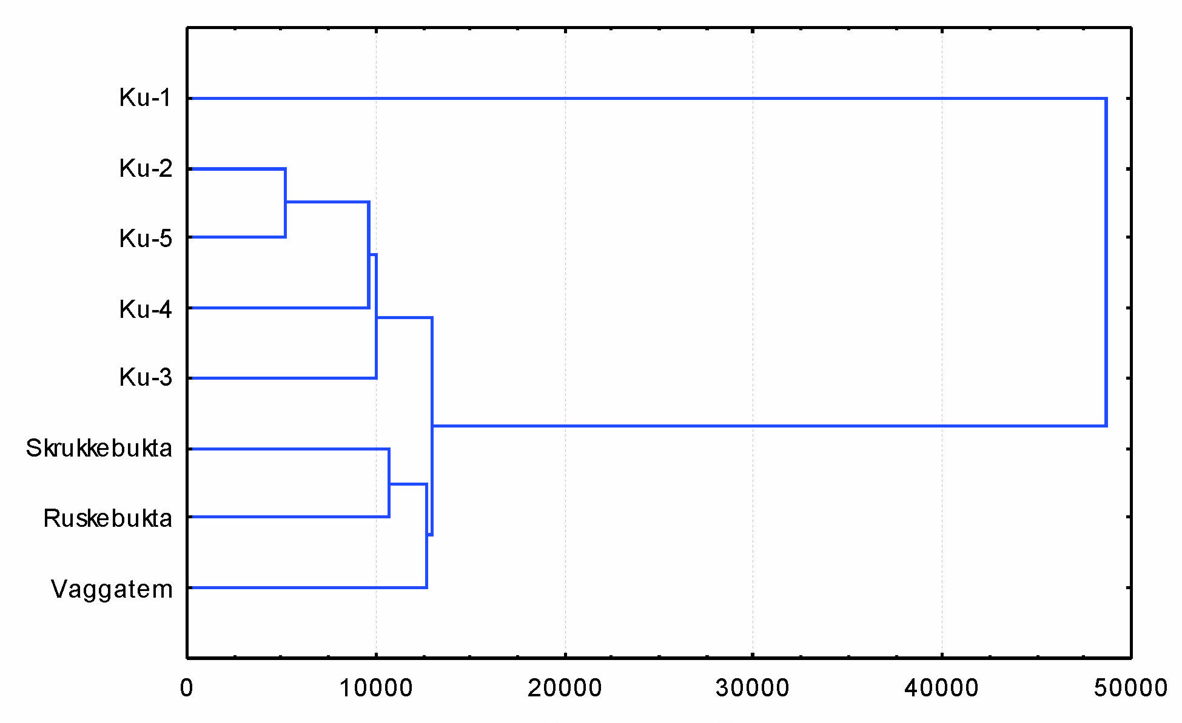
Fig. 8. Dendrogram of cluster analysis of chemical composition of surface (0-1 cm) layer of water bodies BS of the Pasvik River catchment area.

Contamination factor and extent of lake bottom sediments
Contamination intensity of water bodies could be estimated by comparison of HM concentrations in the surface layer of BS and background values. Determination methods of contamination factors and extent of HM water ecosystems in BS using C_{f} and C_{d} are described in (Håkanson, 1980, 1984). Determination methods of BS industrial enrichment factor are described in (Alhonen, 1986; Ouellert, Jones, 1983; Tolonen, Jaakkola, 1983) Estimated values of C_{f} and C_{d} are given in Table 6.
Maximum values of C_{f} almost for all the HM under study are observed in the BS of Lake Kuetsjarvi (Table 6), which is connected with direct inflow of industrial waste waters of the Pechenganikel integrated plant. According to Håkanson’s classification (Håkanson, 1980), Lake Kuetsjarvi is characterized by high C_{f} values for all the HM but Zn (except for station 3) and Pb, for which moderate and considerable contamination was observed. Stations 1 (Ni), 3 (Zn, Co, and As), 4 (Cu), 5 (Cd, Pb, Hg) are characterized by the higher contamination factors. In general, the highest value of contamination extent was recorded at the deepest station 1 (White Stone).
Impact by the waste water from the Pechenganikel integrated plant, manifesting in significant Ni contamination was also observed downstream in Lake Skrukkebukta. The C_{f} values for Cu and Cd are on the border line between moderate and considerable, moderate contamination is observed for the other metals (Table 6).

Table 6. HM concentrations (in µg/g of dry weight) in the surface (0-1 сm) and background layers and values of contamination factor (C_{f}) and contamination degree (C_{d}) of water bodies of the Pasvik River system
Station | Layers | Cu | Ni | Zn | Co | Cd | Pb | As | Hg | C_{d}
Kuetsjärvi-1 | 0-1 | 2000 | 4978 | 309 | 297 | 3.82 | 32.4 | 147.20 | 0.536
White Stone | 15-16 | 58 | 62 | 120 | 27 | 0.09 | 11.9 | 4.77 | 0.025
 | C_{f} | 34.3 | 80.1 | 2.6 | 11.1 | 44.4 | 2.7 | 30.8 | 21.8 | 227.9
Kuetsjärvi-2 | 0-1 | 720 | 2870 | 277 | 133 | 1.40 | 26.5 | 51.82 | 0.702
Golfstream | 14-15 | 58 | 62 | 120 | 27 | 0.09 | 11.9 | 4.77 | 0.025
 | C_{f} | 12.4 | 46.2 | 2.3 | 5.0 | 16.3 | 2.2 | 10.9 | 28.5 | 123.7
Kuetsjärvi-3 | 0-1 | 1403 | 4425 | 775 | 505 | 3.18 | 35.8 | 118.20 | 0.808
Salmijärvi | 11-12 | 58 | 62 | 120 | 27 | 0.09 | 11.9 | 4.77 | 0.025
 | C_{f} | 24.1 | 71.2 | 6.4 | 18.9 | 37.0 | 3.0 | 24.8 | 32.8 | 218.2
Kuetsjärvi-4 | 0-1 | 2305 | 3127 | 248 | 183 | 1.83 | 43.9 | 60.72 | 0.760
Kolosjoki | 6-7 | 58 | 62 | 120 | 27 | 0.09 | 11.9 | 4.77 | 0.025
 | C_{f} | 39.6 | 50.3 | 2.1 | 6.9 | 21.3 | 3.7 | 12.7 | 30.9 | 167.4
Kuetsjärvi-5 | 0-1 | 2039 | 3465 | 338 | 244 | 4.04 | 47.0 | 70.52 | 1.000
Shuonijoki | 12-13 | 58 | 62 | 120 | 27 | 0.09 | 11.9 | 4.77 | 0.025
 | C_{f} | 35.0 | 55.8 | 2.8 | 9.1 | 47.0 | 4.0 | 14.8 | 40.6 | 209.1
 | 0-1 | 169 | 280 | 127 | 39 | 0.27 | 26.8 | 6.9 | 0.017
Skrukkebukta | 9-10 | 58 | 64 | 123 | 25 | 0.09 | 14.0 | 9.0 | 0.032
 | C_{f} | 2.9 | 4.3 | 1.0 | 1.6 | 3.0 | 1.9 | 0.8 | 0.5 | 16.1
 | 0-1 | 75 | 87 | 122 | 28 | 0.11 | 15.6 | 7.6 | 0.042
Vaggatem | 14-15 | 55 | 58 | 126 | 30 | 0.08 | 9.2 | 6.0 | 0.015
 | C_{f} | 1.4 | 1.5 | 1.0 | 1.0 | 1.5 | 1.7 | 1.3 | 2.9 | 12.1
 | 0-1 | 67 | 70 | 95 | 21 | 0.15 | 17.2 | 8.5 | 0.161
Ruskebukta | 14-15 | 62 | 63 | 112 | 26 | 0.09 | 12.4 | 4.4 | 0.038
 | C_{f} | 1.1 | 1.1 | 0.8 | 0.8 | 1.7 | 1.4 | 2.0 | 4.2 | 13.1

Among the lakes situated upstream from the Pechenganikel integrated plant waste water inflow, high Hg contamination is found in Lake Ruskebukta. Low and moderate values of C_{f} are observed for other metals in Lakes Ruskebukta and Vaggatem (Table 6).
In general, Lake Kuetsjarvi (high value of C_{d}, Table 6) is characterized by the maximum contamination by all the contaminants under study. Lake Skrukkebukta has C_{d} value on the boundary between low and moderate. Low values of C_{d} are recorded in Lakes Vaggatem and Ruskebukta.

CONCLUSION

The highest background concentrations of most of the HM (Ni, Zn, Co, Cd, Hg, and As) in the BS are observed in the southern part of Lake Kuetsjarvi which is accounted for by the geochemical (presence of copper-nickel sulphide deposits in the south-western part of lake drainage) and morphometric peculiarities of the lake itself and its catchment area. High Pb concentrations are discovered in the deepest layers of the BS cores in Lakes Ruskebukta and Skrukkebukta. In general, the average background concentrations of almost all the HM (except Cd) in the catchment water bodies of the Pasvik River are higher than the average background concentrations of metals in BS in the North-West of Murmansk Region and the border territories of the neighbouring countries.
The impact of the Pechenganikel integrated plant operation results into the maximum concentrations of all the investigated HM in the surface layers of the BS of Lake Kuetsjarvi. Almost all the HM have surface maximum in the BS of Lake Kuetsjarvi. Zn at stations 4 and 5, Cd at station 4, and As at station 3 are exceptions. Mercury shows the maximum concentrations at depth 2-4 cm of the BS almost at all the lake stations. Despite the reduction of discharge into Lake Kuetsjarvi and atmospheric emissions of HM by the Pechenganikel integrated plant, the content decrease of the main part of HM in the BS surface layers of Lake Kuetsjarvi is not observed.
Maximum concentrations of Ni, Cu, Co, Cd, and Pb are found in the upper 1-cm layer of BS downstream the Pasvik River from the place of waste water inflow into Lake Skrukkebukta. A large increase of HM concentrations in comparison to the background is distinguished in the upper 3 cm of the BS in Lake Skrukkebukta.
In the lakes upstream the Pasvik River from the waste water inflow, in Lakes Vaggatem and Ruskebukta, no great changes in the vertical distribution of Ni, Cu, Co, and Zn concentrations are found in the water bodies’ BS, although there is a slight increase of Ni and Cu concentration in the upper 4 cm of the BS in Lake Vaggatem. However, a tendency of chalcophylic elements (Pb, Cd, Hg, and As) concentration increase was discovered in the surface layers of Lakes Ruskebukta and Vaggatem in comparison to the background content. The largest increase is observed in Lake Ruskebukta for Hg.
The geochemical peculiarities of Lake Kuetsjarvi, primarily, good supply of the bottom water layers and the upper BS layers with dissolved oxygen, as well as the large depth of the water body has resulted in accumulation of elements sensitively responding to changes of redox potential – Fe and Mn – in the BS surface parts. The content of these mobile elements in the BS surface layers of the lakes exceeds the bulk earth and background values 10-50 times.
The P content increase in the surface layers of BS is distinguished in the lakes under study may be an evidence of eutrophication process, connected with inflow of household sewage and regulation of the flow leading to the flow deceleration, stagnations and, finally, accumulation of biogenic elements in the water ecosystems. The accumulated P in the BS can be a source of this biogenic element into the water strata.
In general, Lake Kuetsjarvi (high value of C_{d} contamination degree) is characterized by the maximum contamination by all the contaminating elements under study. Lake Skrukkebukta has the C_{d} value on the boundary between low and moderate. Low values of C_{d} are found in Lakes Vaggatem and Ruskebukta.

REFERENCES

Alhonen P. Heavy metal load of Lake Iidesjarvi as reflected in its sediments // Aqua Fennica. 1986. V. 16, No 1. P. 11-16.
Baklanov А.А, Makarova Т.D. Contamination with sulfuric gas in the area of Soviet-Norwegian border // Ecological and geographical problems of the Kola North. Apatity: Kola SC RAS Publication, 1992. P. 114-129.
Dauvalter V. Concentrations of heavy metals in superficial lake sediments of Pechenga district, Murmansk region, Russia // Vatten. 1992. V. 48, No 2. P. 141-145.
Dauvalter V. Heavy metals in lake sediments of the Kola peninsula, Russia // Sci. Total Environ. 1994. V. 158. P. 51-61.
Dauvalter V.А. Heavy metal concentrations in bottom sediments of the Kola Peninsula lakes as an indicator of contamination of aquatic ecosystems // Problems of chemical and biological monitoring of ecological state of water bodies of the Kola North. Apatity: Kola SC RAS Publication, 1995. P. 24-35.
Dauvalter V. Metal concentrations in sediments in acidifying lakes in Finnish Lapland // Boreal Environ. Res. 1997. V. 2. P. 369-379.
Dauvalter V.А. Contamination of bottom sediments in the Pasvik River catchment area with heavy metals // Geoecology. 1997. № 6. P. 43-53.
Dauvalter V.А. Concentration of metals in bottom sediments of acid lakes // Water Resources. – 1998. – V. 25, No. 3. – P. 328-335.
Dauvalter V.А. Heavy metals in the bottom sediments of the Inari-Pasvik lake-river system // Water Resources. – 1998. – V. 25, No. 4. – P. 451-457.
Dauvalter V.А. Appropriateness of sedimentation in water objects of European Subarctic (nature protection aspects of problem) // DrSci Thesis. Apatity. KSC RAS, 1999. 399 p.
Dauvalter V.А. Chemical composition of subarctic lake sediments under influence of mining and metallurgical activities // Izvestiya of Russian Academy of Sciences. Geography series. V. 4. P. 65-73.
Dauvalter V. Impact of mining and refining on the distribution and accumulation of nickel and other heavy metals in sediments of subarctic lake Kuetsjärvi, Murmansk region, Russia // J. Environ. Monitor. 2003. V. 5 (2). P. 210-215.
Dauvalter V.А. Chalcophile elements (Hg, Cd, Pb, and As) in bottom sediments of water bodies of the White Sea catchment area on the Kola Peninsula // Geochemistry International. – 2006. – V. 44, No. 2. – P. 205–208.
Dauvalter V., Rognerud S. Heavy metals pollution in sediment of the Pasvik River drainage // Chemosphere. 2001. V. 42, No 1. P. 9-18.
Dauvalter V.A., Ilyashuk B.P. Conditions of formation of ferromanganese nodules in the bottom sediments of lakes in the Baltic Shield // Geochemistry International. – 2007. – Vol. 45, No. 6. – P. 615–619.
Förstner U. Lake sediments as indicator of heavy-metal pollution // Naturwissenschaften. 1976. V. 63. P. 465-470.
Goncharova Т.О., Ivanova А.А., Kaplin V.Т., Borisova А. SH., Norina А.М., Titkova Е.N., Sorokina E.F. Contamination characteristics of some water bodies of Murmansk Region by waste water акщь ore-enrichment integrated plants // Hydrochemical materials. 1973. V. 2. P. 129-138.
Gregurek D., Melcher F., Pavlov V.A., Reimann C., Stumpf E.F. Mineralogy and mineral chemistry of snow filter residues in the vicinity of the nickel-copper processing industry, Kola Peninsula, NW Russia // Miner. Petrol. 1999. V. 65. P. 87-111.
Hagen L.O., Aarnes M.J., Henriksen J.F., Sivertsen B. Basisundersokelse av luftforurensinger i Sor-Varanger 1988-1991. Oslo: NILU-report 67/91, 1991. 89 p.
Håkanson L. An ecological risk index for aquatic pollution control – a sedimentological approach // Water Res. 1980. V. 14. P. 975-1001.
Håkanson L. Sediment sampling in different aquatic environments: Statistical aspects // Water Resour. Resear. 1984. V. 20, No 1. P. 41-46.
Håkanson L., Jansson M. Principles of lake sedimentology. Berlin: Springer-Verlag, 1983. 316 p.
Hellsten S., Visuri M., Partanen S., Järvinen E.A., Keto A., Marttunen M. The Paatsjoki Barents Interreg II Project: Development of a tool to describe the effects of water level regulation and different discharge regimes on the ecological conditions of river Paatsjoki water system. Oulu, Finland Finnish Environment Institute, Hydrology and water management division. Final report, 2001. 34 p.
Johansson K. Metals in sediments of lakes in Northern Sweden // Water Air Soil Pollut. 1989. V. 47. P. 441-457.
Kashukin N.A., Sandimirov S.S., Dauvalter V.А., Terentiev P.M., Denisov D.B. Ecological catalogue of lakes of Murmansk Region. The North-western part of Murmansk Region and boundary territory of the contiguous countries. – Apatity: Kola SC RAS Publication, 2009. – P. I. – 226 p.
Kriuchkov V.V., Makarova T.D. Aerotechnogenic impact on ecosystems of the Kola North. Apatity: Kola SC RAS Publication, 1989. 96 p.
Lennox L.J. Sediment-water exchange in Lough Ennel with particular reference to phosphorus // Wat. Res. 1984. Vol. 18, No. 12. P. 1483-1485.
Lewis T.E., McIntosh A.W. Covariation of selected trace elements with binding substrates in cores collected from two contaminated sediments // Bull. Environ. Contam. Toxicol. 1989. V. 43. P. 518-528.
Malinovsky, D.N.; Rodyushkin, I.V.; Shcherbakova, E.P.; Ponter, C.; Öhlander, B.; Ingri, J. Fractionation of Fe isotopes as a result of redox processes in a basin. Geochem. Int. 2005, 43, 797–803.
Moiseenko T., Mjelde M., Brandrud T., Brettum P., Dauvalter V., Kagan L., Kashulin N., Kudriavtseva L., Lukin A., Sandimirov S., Traaen T.S., Vandysh O., Yakovlev V. Pasvik River Watercourse, Barents Region: Pollution Impacts and Ecological Responses. Investigations in 1993. Oslo: NIVA-report OR-3118. 1994. 87 p.
Moiseenko T.I., Kudryavtseva L.P., Rodyushkin I.V., Dauvalter V.A., Lukin A.A. and Kashulin N.A. Airborne contamination by heavy metals and aluminium in the freshwater ecosystems of the Kola subarctic region (Russia) // Sci. Tot. Environ. 1995. V. 160/161. P. 715-727.
Moiseenko Т.I., Dauvalter V.А., Lukin A.A., Kudryavsteva L.P., Ilyashuk B.P., Ilyashuk E.A., Sandimirov S.S., Kagan L.Ya., Vandysh O.I., Sharov A.N., Sharova Yu.N., Koroleva I.M., (Under the editorship of Moiseenko T.I.) Anthropogenic modifications of Lake Imandra ecosystem. М: Science, 2002. 487 p.
Moiseenko T., Dauvalter V., Rodushkin I. Mechanisms of the cycle of natural and human–introduced metals in surface waters of the Arctic basin // Water Resources. – 1998. – V. 25, No. 2. – P. 212-224.
Norton S.A., Bienert R.W.J., Binford M.W., Kahl J.S. Stratigraphy of total metals in RIPLA sediment cores // Paleolimnol. 1992. V. 7. P. 191-214.
Norton S.A., Dillon P.J., Evans R.D., Mierle G., Kahl J.S. The history of atmospheric deposition of Cd, Hg and Pb in North America: Evidence from lake and peat bog sediments // Lindberg S. E. et al. (Eds.). Sources, Deposition and Capony Interactions. V. III, Acidic Precipitation. New York: Springer-Verlag, 1990. P. 73-101.
Norton S.A., Henriksen A., Appleby P.G. Ludwig L.L., Vereault D.V., Traaen T.S. Trace metal pollution in eastern Finnmark, Norway, as evidenced by studies of lake sediments. Oslo: SFT-report 487/92, 1992. 42 p.
Ouellert M., Jones H.G. Paleolimnological evidence for the long-range atmospheric transport of acidic pollution and heavy metals into Quebec, Canada // Can. J. Earth Sci. 1983. V. 20. P. 23-26.
Pacyna J.M., Pacyna E.G. An assessment of global and regional emissions of trace elements to the atmosphere from anthropogenic sources worldwide // Environ. Rev. 2001. V. 4. P. 269-298.
Rekolainen S., Verta M., Liehu A. The effect of airborne mercury and peatland drainage on sediment mercury content in some Finnish forest lakes // Helsinki: National Board of Water. 1986. V. 65. P. 11-21.
Rognerud S. Sedimentundersøkelser i Pasvikela høsten 1989. Oslo: NIVA-Rapport 401/90, 1990. 10 p.
Rognerud S., Fjeld E. National survey of heavy metals in lake sediments and mercury in fish. Oslo: SFT-report 426/90, 1990. 77 p.
Rognerud S., Fjeld E. Regional survey of heavy metals in lake sediments in Norway // AMBIO. 1993. V. 22, № 4. P. 206-212.
Rognerud S., Norton S.A., Dauvalter V. Heavy metal pollution in lake sediments in the border areas between Russia and Norway. Oslo: NIVA-Report 522/ 93, 1993. 18 p.
Ruhling A., Rasmussen L., Pilegaard K. Survey of atmospheric heavy metal deposition. Copenhagen: Nordic Council Ministers, 1987. 44 p.
Sandman O, Eskonen K, Liehu A. The eutrophication history of Lake Särkinen, Finland and the effects of lake aeration // Hydrobiologia. 1990. V. 214. P. 191-199.
Schindler D.W., Hesslein R.H., Wagemann R., Broecker W.S. Effects of acidification on mobilization of heavy metals and radionuclides from sediments of freshwater lakes // Can. J. Fish. Aquat Sci. 1980 V. 37. P. 373-377.
Shaw J.F.H., Prepas E.E. Relationships between phosphorus in shallow sediments and in the trophogenic zone of seven Alberta lakes // Wat. Res. 1990. Vol. 24, No. 5. P. 551-556.
Skogheim O.K. Rapport fra Arungenprosjektet. Oslo: As- NLH, Nr. 2, 1979. 7 p.
Steinnes E., Franzen F., Johansen O., Rambak J.P., Hansen J.E. Atmosfarisk nedfall av tungmetaller i Norge. Landsjamfattendt undersokelse i 1985. Oslo: SFT-rapport 334/88, 1988. 33 p.
Tenhola M., Lummaa M. Regional distribution of zinc in lake sediments from eastern Finland // Symposium on Economic Geology, Dublin, Ireland, 26-29 August, 1979. P. 67-73.
Tolonen K., Jaakkola T. History of lake acidification and air pollution studied on sediments in South Finland // Ann. Bot. Fennici. 1983. V. 20. P. 57-78.
Verta M., Tolonen K., Simola H. History of heavy metal pollution in Finland as recorded by lake sediments // Sci. Tot. Environ. 1989.V. 87/88. P. 1-18.

